Glide Reflection

Definition
# Source: AI Source: Provided by: [Data Path: Persons Table -> ID Column: 1, Name_En Column: Motasem Essam] -> From: [ChatGPT] on [7/25/2026]
A Glide Reflection is a geometric transformation that combines:
- a reflection across a line, and
- a translation along that same line.
The reflection is performed first, followed by a translation parallel to the line of reflection.
A glide reflection preserves distances, angles, shape, and size, but it reverses orientation.

Fundamental Concept
# Source: AI Source: Provided by: [Data Path: Persons Table -> ID Column: 1, Name_En Column: Motasem Essam] -> From: [ChatGPT] on [7/25/2026]
A glide reflection can be represented as:
$$\boxed{\text{Glide Reflection}=\text{Reflection}+\text{Translation}}$$
Suppose a figure is reflected across a line $l$, and then every point is translated by a vector $\vec{v}$that is parallel to $l$.
The resulting figure is congruent to the original figure.
For a point $P$:
$$P\underset{→}{\text{Reflection across }l}P^{'}\underset{→}{\text{Translation along }l}P^{''}$$
The final point $P^{''}$is the image of $P$under the glide reflection.
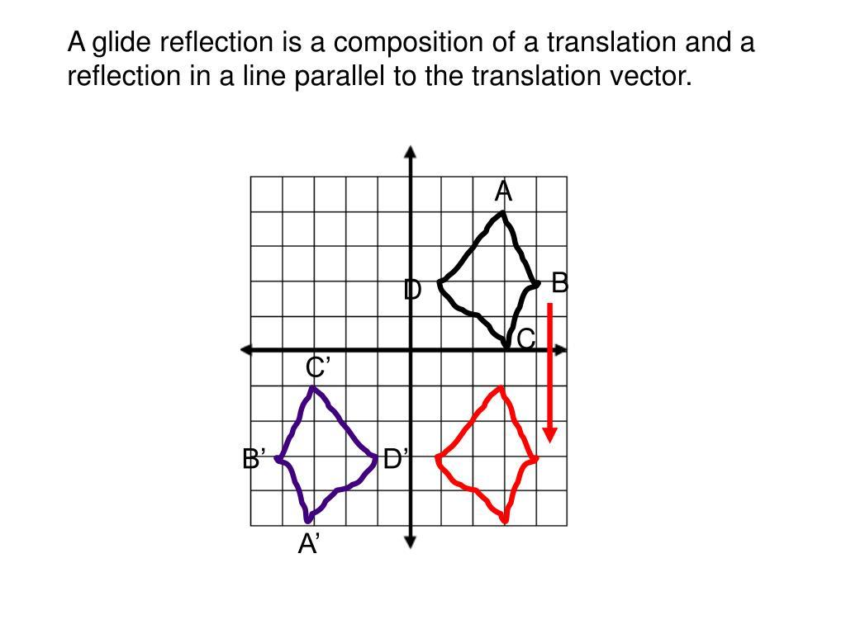
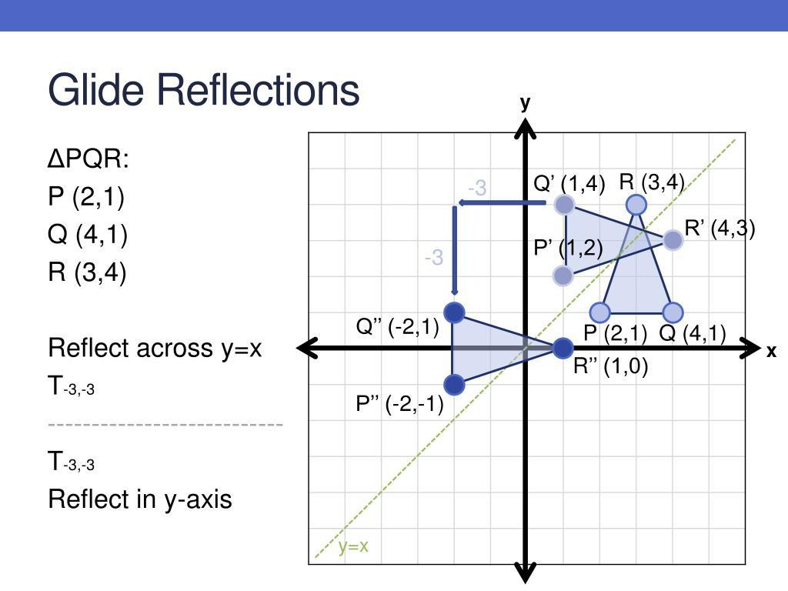
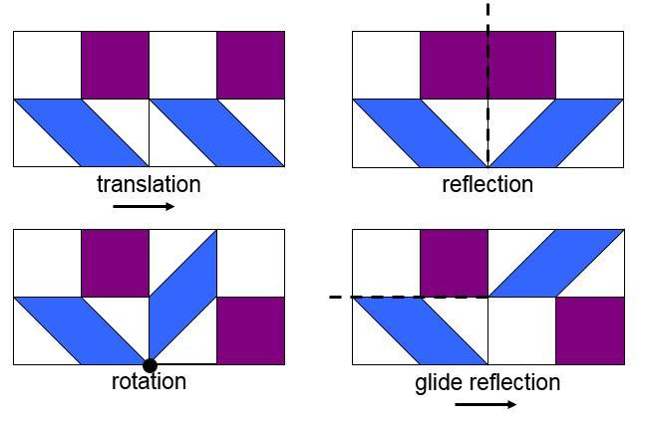
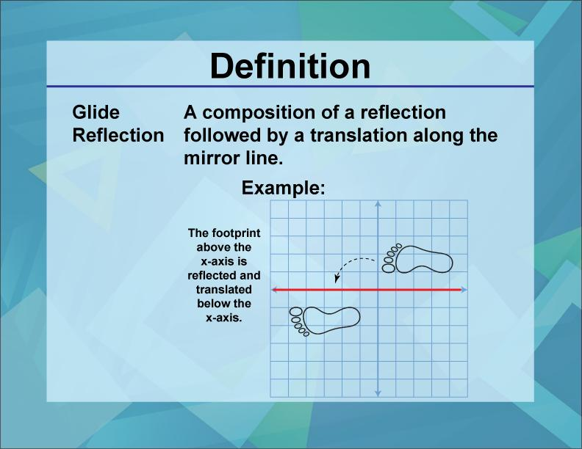
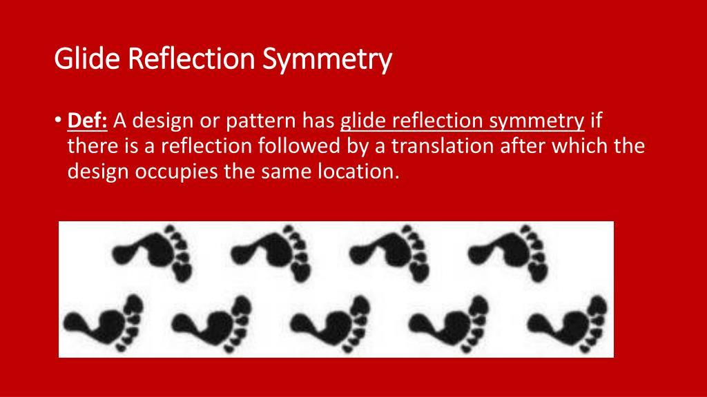

Basic Structure
# Source: AI Source: Provided by: [Data Path: Persons Table -> ID Column: 1, Name_En Column: Motasem Essam] -> From: [ChatGPT] on [7/25/2026]
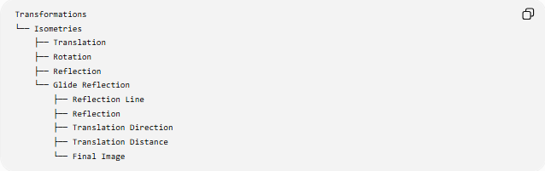
Transformations
└── Isometries
├── Translation
├── Rotation
├── Reflection
└── Glide Reflection
├── Reflection Line
├── Reflection
├── Translation Direction
├── Translation Distance
└── Final Image
A glide reflection therefore has two essential components:

Component | Function
Reflection | Flips the figure across a line
Translation | Moves the reflected figure along that line

Main Characteristics
# Source: AI Source: Provided by: [Data Path: Persons Table -> ID Column: 1, Name_En Column: Motasem Essam] -> From: [ChatGPT] on [7/25/2026]
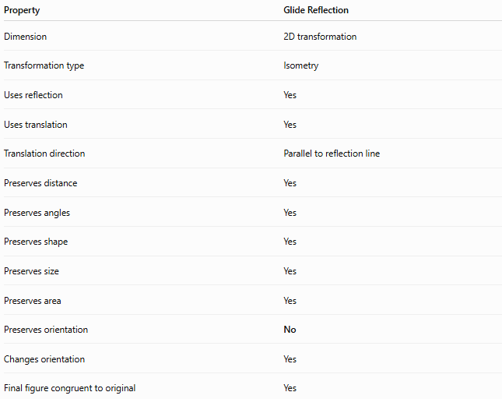
Property | Glide Reflection
Dimension | 2D transformation
Transformation type | Isometry
Uses reflection | Yes
Uses translation | Yes
Translation direction | Parallel to reflection line
Preserves distance | Yes
Preserves angles | Yes
Preserves shape | Yes
Preserves size | Yes
Preserves area | Yes
Preserves orientation | No
Changes orientation | Yes
Final figure congruent to original | Yes

Reflection Line
# Source: AI Source: Provided by: [Data Path: Persons Table -> ID Column: 1, Name_En Column: Motasem Essam] -> From: [ChatGPT] on [7/25/2026]
The reflection line is the line across which the initial reflection occurs.
For example, consider reflection across the $x$-axis:
$$\left(x , y\right)→\left(x , -y\right)$$
The $x$-axis is the reflection line.
The subsequent translation must occur parallel to the $x$-axis.

Translation Component
# Source: AI Source: Provided by: [Data Path: Persons Table -> ID Column: 1, Name_En Column: Motasem Essam] -> From: [ChatGPT] on [7/25/2026]
After reflection, the reflected figure is translated along the reflection line.
For example, a translation of $d$units to the right is:
$$\left(x , y\right)→\left(x , +dy\right)$$
If the reflection line is the $x$-axis, a glide reflection could therefore be:
$$\boxed{\left(x , y\right)→\left(x , +d-y\right)}$$
where $d$is the translation distance.

Mathematical Representation
# Source: AI Source: Provided by: [Data Path: Persons Table -> ID Column: 1, Name_En Column: Motasem Essam] -> From: [ChatGPT] on [7/25/2026]
Consider a glide reflection across the $x$-axis followed by a horizontal translation of $d$.
Step 1 — Reflection
$$\left(x , y\right)→\left(x , -y\right)$$
Step 2 — Translation
$$\left(x , -y\right)→\left(x , +d-y\right)$$
Therefore:
$$\boxed{\left(x , y\right)→\left(x , +d-y\right)}$$
This is the coordinate form of a glide reflection across the $x$-axis with translation distance $d$.

General Vector Form
# Source: AI Source: Provided by: [Data Path: Persons Table -> ID Column: 1, Name_En Column: Motasem Essam] -> From: [ChatGPT] on [7/25/2026]
Let the reflection be across a line $l$, and let the translation vector be $\vec{v}$, where
$$\vec{v}∥l$$
Then:
$$\boxed{G=T_{\vec{v}}∘R_{l}}$$
where:
- $R_{l}$= reflection across line $l$
- $T_{\vec{v}}$= translation by vector $\vec{v}$
- $G$= glide reflection
The composition means:
$$P\underset{→}{R_{l}}P^{'}\underset{→}{T_{\vec{v}}}P^{''}$$

Example
# Source: AI Source: Provided by: [Data Path: Persons Table -> ID Column: 1, Name_En Column: Motasem Essam] -> From: [ChatGPT] on [7/25/2026]
Suppose a point is:
$$P=\left(2 , 3\right)$$
Perform a glide reflection across the $x$-axis followed by a translation of $5$units to the right.
Reflection
$$\left(2 , 3\right)→\left(2 , -3\right)$$
Translation
$$\left(2 , -3\right)→\left(7 , -3\right)$$
Therefore:
$$\boxed{P^{'}=\left(7 , -3\right)}$$

Glide Reflection of a Figure
# Source: AI Source: Provided by: [Data Path: Persons Table -> ID Column: 1, Name_En Column: Motasem Essam] -> From: [ChatGPT] on [7/25/2026]
Suppose a triangle has vertices:
$$A\left(1 , 2\right), B\left(3 , 2\right), C\left(2 , 4\right)$$
Reflect across the $x$-axis:
$$A^{'}\left(1 , -2\right) \\ B^{'}\left(3 , -2\right) \\ C^{'}\left(2 , -4\right)$$
Then translate 4 units to the right:
$$A^{''}\left(5 , -2\right) \\ B^{''}\left(7 , -2\right) \\ C^{''}\left(6 , -4\right)$$
The final triangle has exactly the same side lengths and angles as the original.
Thus:
$$\boxed{△ABC≅△A^{''}B^{''}C^{''}}$$

Properties of Glide Reflection

1-Distance Preservation
# Source: AI Source: Provided by: [Data Path: Persons Table -> ID Column: 1, Name_En Column: Motasem Essam] -> From: [ChatGPT] on [7/25/2026]
For any two points $P$and $Q$:
$$PQ=P^{'}Q^{'}$$
Therefore, a glide reflection is an isometry.

2-Angle Preservation
# Source: AI Source: Provided by: [Data Path: Persons Table -> ID Column: 1, Name_En Column: Motasem Essam] -> From: [ChatGPT] on [7/25/2026]
The measure of an angle is preserved:
$$m∠ABC=m∠A^{'}B^{'}C^{'}$$
although the orientation of the angle is reversed.

3-Area Preservation
# Source: AI Source: Provided by: [Data Path: Persons Table -> ID Column: 1, Name_En Column: Motasem Essam] -> From: [ChatGPT] on [7/25/2026]
Because distances and shapes are preserved:
$$\boxed{A^{'}=A}$$

4-Shape Preservation
# Source: AI Source: Provided by: [Data Path: Persons Table -> ID Column: 1, Name_En Column: Motasem Essam] -> From: [ChatGPT] on [7/25/2026]
The image has exactly the same geometric shape as the original.
Thus:
$$\boxed{\text{Original Shape}≅\text{Image Shape}}$$

5-Orientation Reversal
# Source: AI Source: Provided by: [Data Path: Persons Table -> ID Column: 1, Name_En Column: Motasem Essam] -> From: [ChatGPT] on [7/25/2026]
A glide reflection reverses orientation because it contains a reflection.
For example, a clockwise ordering of vertices becomes counterclockwise.

Glide Reflection vs Reflection
# Source: AI Source: Provided by: [Data Path: Persons Table -> ID Column: 1, Name_En Column: Motasem Essam] -> From: [ChatGPT] on [7/25/2026]
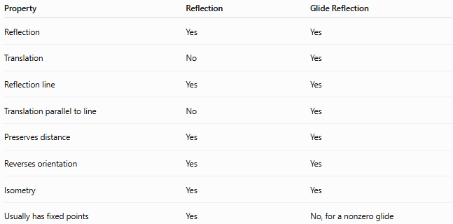
Property | Reflection | Glide Reflection
Reflection | Yes | Yes
Translation | No | Yes
Reflection line | Yes | Yes
Translation parallel to line | No | Yes
Preserves distance | Yes | Yes
Reverses orientation | Yes | Yes
Isometry | Yes | Yes
Usually has fixed points | Yes | No, for a nonzero glide
A glide reflection is therefore more than an ordinary reflection because the reflected figure is also shifted.

Glide Reflection vs Translation
# Source: AI Source: Provided by: [Data Path: Persons Table -> ID Column: 1, Name_En Column: Motasem Essam] -> From: [ChatGPT] on [7/25/2026]
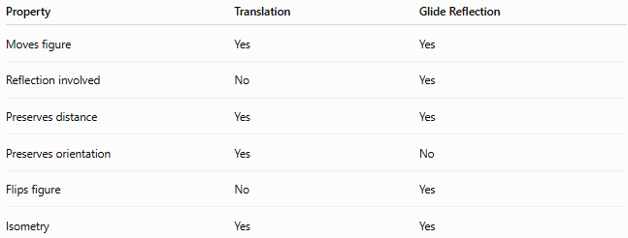
Property | Translation | Glide Reflection
Moves figure | Yes | Yes
Reflection involved | No | Yes
Preserves distance | Yes | Yes
Preserves orientation | Yes | No
Flips figure | No | Yes
Isometry | Yes | Yes

Glide Reflection vs Rotation
# Source: AI Source: Provided by: [Data Path: Persons Table -> ID Column: 1, Name_En Column: Motasem Essam] -> From: [ChatGPT] on [7/25/2026]
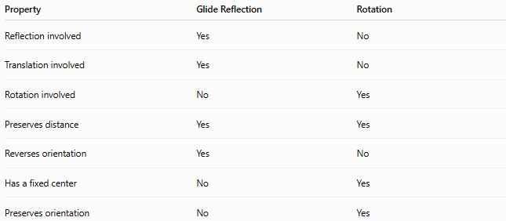
Property | Glide Reflection | Rotation
Reflection involved | Yes | No
Translation involved | Yes | No
Rotation involved | No | Yes
Preserves distance | Yes | Yes
Reverses orientation | Yes | No
Has a fixed center | No | Yes
Preserves orientation | No | Yes

Glide Reflection Symmetry
# Source: AI Source: Provided by: [Data Path: Persons Table -> ID Column: 1, Name_En Column: Motasem Essam] -> From: [ChatGPT] on [7/25/2026]
A figure has glide reflection symmetry if applying a glide reflection maps the figure onto itself.
In symbolic form:
$$\boxed{G\left(S\right)=S}$$
where $S$is the figure and $G$is the glide reflection.
This means that after reflecting and translating the figure, it coincides with the original figure.
Glide reflection symmetry is especially common in:
- repeating patterns
- friezes
- decorative designs
- borders
- footprints
- textile patterns

Important Distinction
# Source: AI Source: Provided by: [Data Path: Persons Table -> ID Column: 1, Name_En Column: Motasem Essam] -> From: [ChatGPT] on [7/25/2026]
A glide reflection transformation and glide reflection symmetry are related but not identical.
Glide Reflection
A transformation:
$$G=T_{\vec{v}}∘R_{l}$$
Glide Reflection Symmetry
A property of a figure:
$$G\left(S\right)=S$$
So:
Glide reflection is the transformation; glide reflection symmetry is the symmetry produced when that transformation maps a figure onto itself.

Special Case
# Source: AI Source: Provided by: [Data Path: Persons Table -> ID Column: 1, Name_En Column: Motasem Essam] -> From: [ChatGPT] on [7/25/2026]
If the translation distance is zero:
$$d=0$$
then:
$$\left(x , y\right)→\left(x , -y\right)$$
which is simply a reflection.
Therefore:
$$\boxed{\text{Glide Reflection with }d=0=\text{Reflection}}$$
A nonzero translation is required for a genuine glide reflection.

Important Geometric Property
# Source: AI Source: Provided by: [Data Path: Persons Table -> ID Column: 1, Name_En Column: Motasem Essam] -> From: [ChatGPT] on [7/25/2026]
The translation must be parallel to the reflection line.
For example, if the reflection line is horizontal:
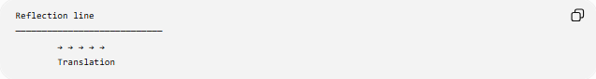
Reflection line
────────────────────────────
→ → → → →
Translation
The translation occurs along the line.
If the translation were perpendicular to the reflection line, the transformation would not be the standard glide reflection.

Classification
# Source: AI Source: Provided by: [Data Path: Persons Table -> ID Column: 1, Name_En Column: Motasem Essam] -> From: [ChatGPT] on [7/25/2026]
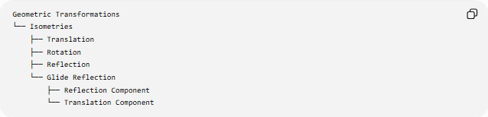
Geometric Transformations
└── Isometries
├── Translation
├── Rotation
├── Reflection
└── Glide Reflection
├── Reflection Component
└── Translation Component
Another useful classification is:
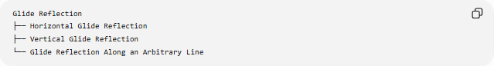
Glide Reflection
├── Horizontal Glide Reflection
├── Vertical Glide Reflection
└── Glide Reflection Along an Arbitrary Line
These describe the direction of the reflection line and corresponding glide.

Coordinate Examples
# Source: AI Source: Provided by: [Data Path: Persons Table -> ID Column: 1, Name_En Column: Motasem Essam] -> From: [ChatGPT] on [7/25/2026]
Reflection across the $x$-axis + rightward translation
$$\boxed{\left(x , y\right)→\left(x , +d-y\right)}$$
Reflection across the $x$-axis + leftward translation
$$\boxed{\left(x , y\right)→\left(x , -d-y\right)}$$
Reflection across the $y$-axis + upward translation
$$\boxed{\left(x , y\right)→\left(- , xy+d\right)}$$
Reflection across the $y$-axis + downward translation
$$\boxed{\left(x , y\right)→\left(- , xy-d\right)}$$

Glide Reflection and Congruence
# Source: AI Source: Provided by: [Data Path: Persons Table -> ID Column: 1, Name_En Column: Motasem Essam] -> From: [ChatGPT] on [7/25/2026]
Because glide reflection is an isometry:
$$\boxed{\text{Original Figure}≅\text{Image Figure}}$$
The following remain unchanged:
- side lengths
- distances
- angle measures
- perimeter
- area
- shape
- size
Only the position and orientation change.

Key Points
# Source: AI Source: Provided by: [Data Path: Persons Table -> ID Column: 1, Name_En Column: Motasem Essam] -> From: [ChatGPT] on [7/25/2026]
- A glide reflection combines a reflection and a translation.
- The translation occurs parallel to the reflection line.
- It is an isometry.
- It preserves distances, angles, perimeter, area, shape, and size.
- It reverses orientation.
- A genuine glide reflection has a nonzero translation component.
- If the translation is zero, the transformation becomes an ordinary reflection.
- Glide reflection symmetry occurs when the transformation maps the figure onto itself.
- Coordinate example:
$$\boxed{\left(x , y\right)→\left(x , +d-y\right)}$$
for reflection across the $x$-axis followed by a translation of $d$units to the right.

Conclusion
# Source: AI Source: Provided by: [Data Path: Persons Table -> ID Column: 1, Name_En Column: Motasem Essam] -> From: [ChatGPT] on [7/25/2026]
A Glide Reflection is an isometric transformation formed by combining a reflection across a line with a translation parallel to that same line. It preserves the figure's size, shape, distances, angles, perimeter, and area, while reversing its orientation. Its general form is
$$\boxed{G=T_{\vec{v}}∘R_{l}, \vec{v}∥l}$$
making glide reflection an important type of geometric symmetry and rigid transformation.

